Default start (regression checkbox is cleared)

Input=

Param0: a1, b2

Param1: c2, d2, e2, f2

Param2: g3, h3, i3

Param3: j4, k4

Press Generate

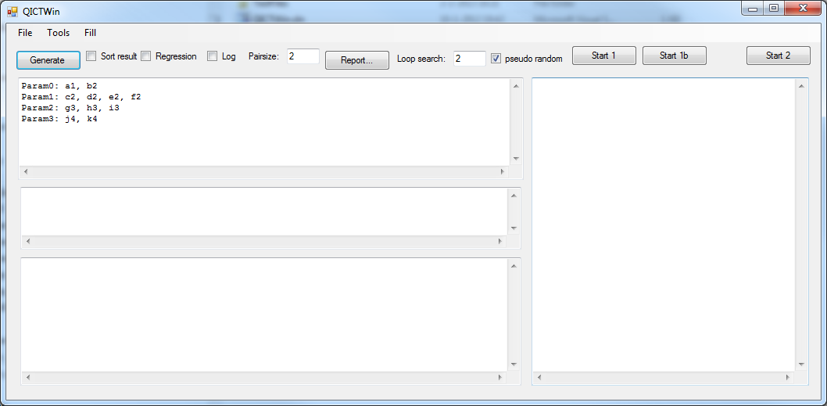

Now pairs are generated and result will be shown

Generated results

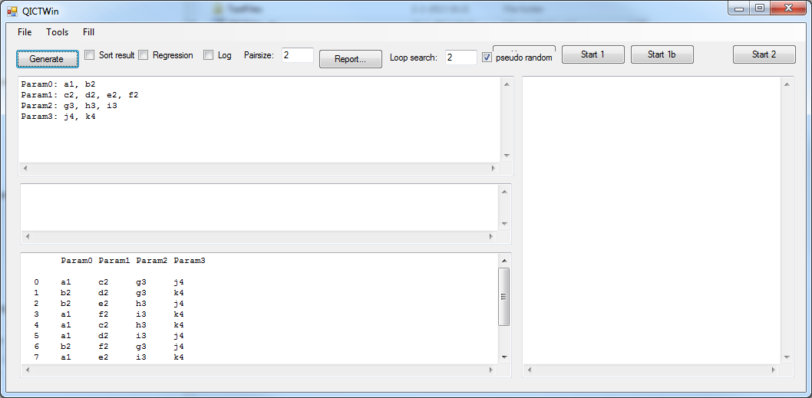

The output contains all parameters with their values; each pair is available. In this case 11 test cases

Param0 Param1 Param2 Param3

0 a1 c2 g3 j4

1 b2 d2 g3 k4

2 b2 e2 h3 j4

3 a1 f2 i3 k4

4 a1 c2 h3 k4

5 a1 d2 i3 j4

6 b2 f2 g3 j4

7 a1 e2 i3 k4

8 b2 c2 i3 j4

9 a1 d2 h3 j4

10 a1 e2 g3 j4

11 a1 f2 h3 j4

REGRESSION:

For Param0 an extra value is added: q3. QICTWin will keep as much as possible test data the same

Param0: a1, b2, q3

Param1: c2, d2, e2, f2

Param2: g3, h3, i3

Param3: j4, k4

The values of the previous generation are added in the middle textbox; the Regression textbox is clicked so new test data set is generated:

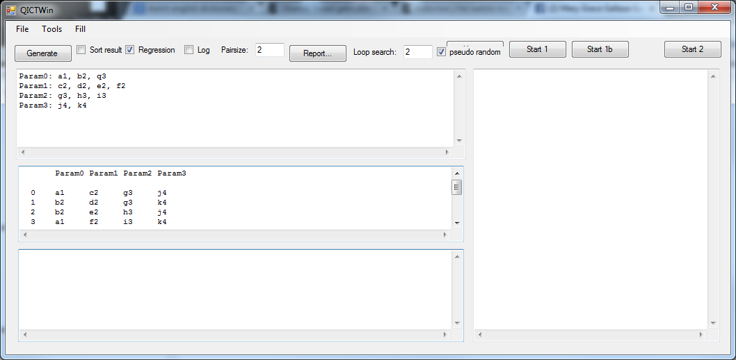

Now pairs are generated with respect to the previous generation and result will be shown

Generated results

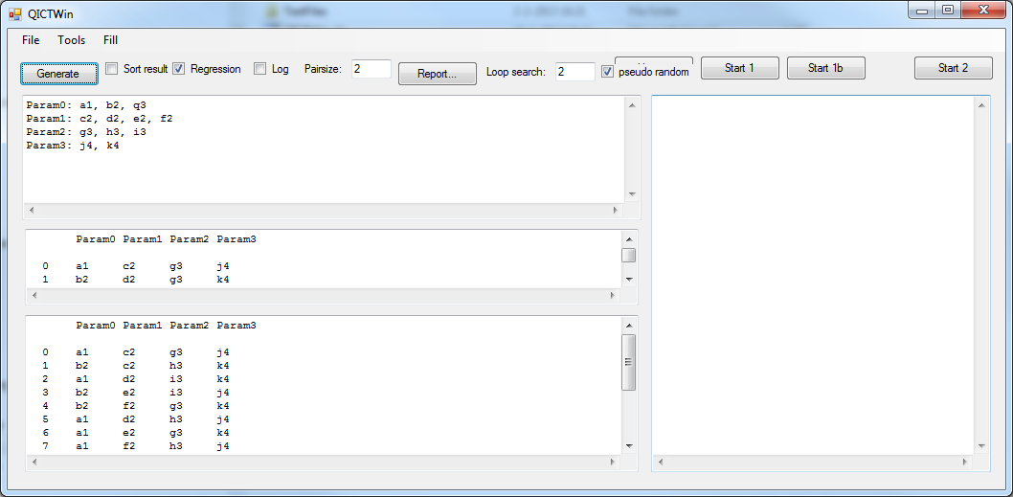

The output contains all parameters with their values; each pair is available. In this case 4 extra test cases

Param0 Param1 Param2 Param3

0 a1 c2 g3 j4

1 b2 c2 h3 k4

2 a1 d2 i3 k4

3 b2 e2 i3 j4

4 b2 f2 g3 k4

5 a1 d2 h3 j4

6 a1 e2 g3 k4

7 a1 f2 h3 j4

8 a1 c2 i3 j4

9 b2 d2 g3 j4

10 a1 e2 h3 j4

11 a1 f2 i3 j4

12 q3 c2 g3 j4

13 q3 d2 h3 k4

14 q3 e2 i3 j4

15 q3 f2 g3 j4

**Extra possibilities:**

**Instead of pairs, this program can also handle triples (3th dimension), 4th dimension etc.**

Several other possibilities (like logging) is partly implemented but because of time at the tax department not fully tested. It is a long time ago already so I need some time to improve and make it fully usable for our colleagues and customers.